Architecture Followed:

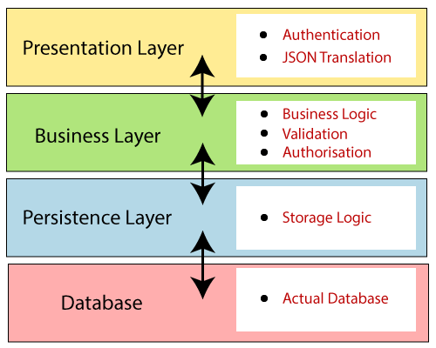
Instead of developing whole application in one unit divided in to seperate layers for more feasible, testability etc.
Following:
Presentation Layer: The presentation layer handles the HTTP requests, translates the JSON parameter to object, and authenticates the request and transfer it to the business layer. In short, it consists of views i.e., frontend part.
Business Layer: The business layer handles all the business logic. It consists of service classes and uses services provided by data access layers. It also performs authorization and validation.
Persistence Layer: The persistence layer contains all the storage logic and translates business objects from and to database rows.
Database Layer: In the database layer, CRUD (create, retrieve, update, delete) operations are performed.

Sequence Diagrams of prediction System through CV analysis:
Sequence Diagram of Registration System:

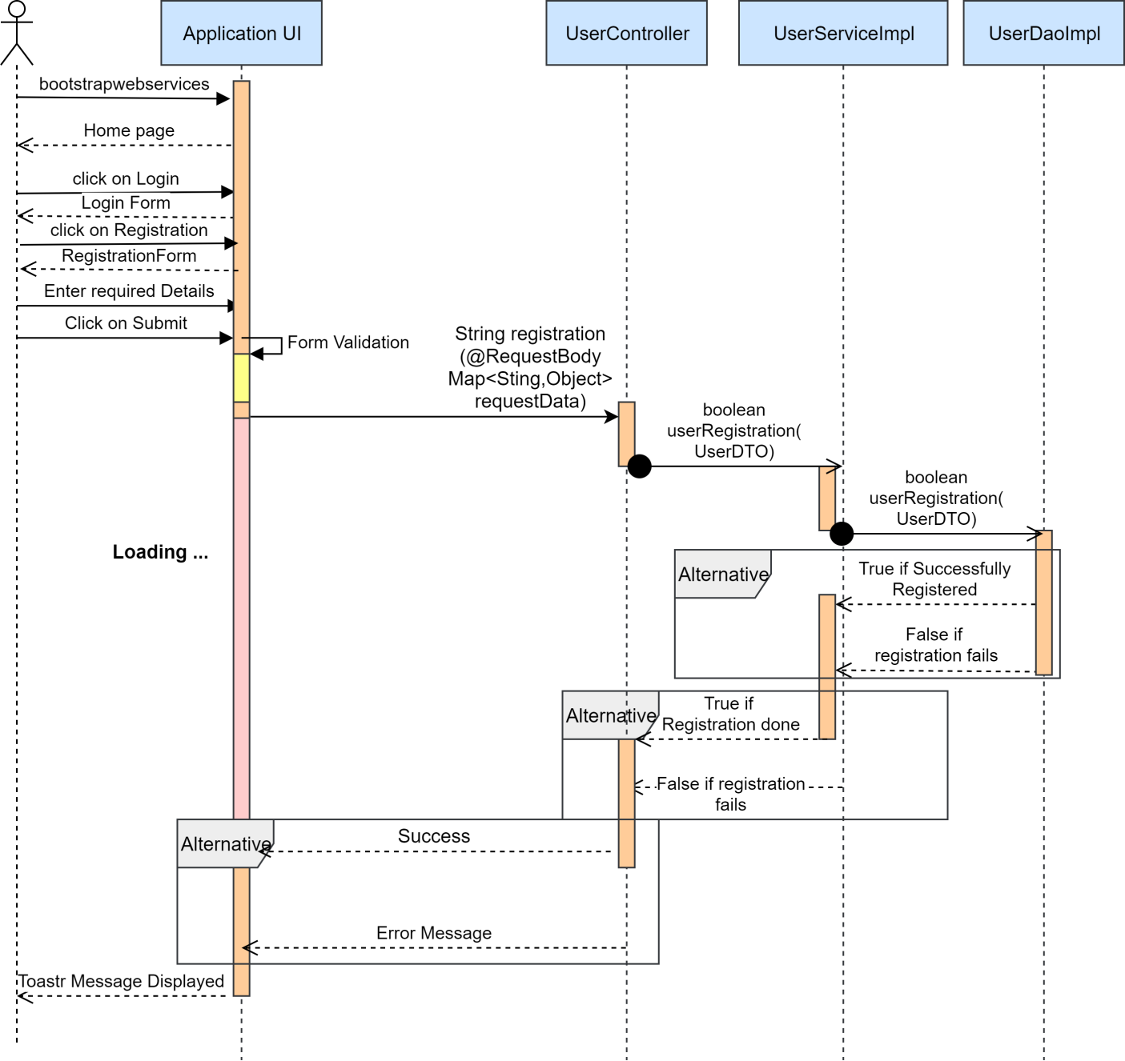

Sequence Diagram of Login system:

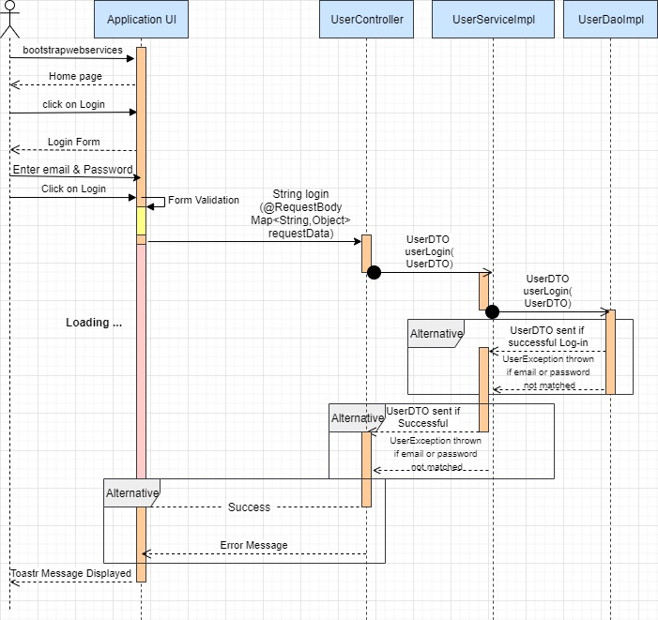

Sequence Diagram of Logout:
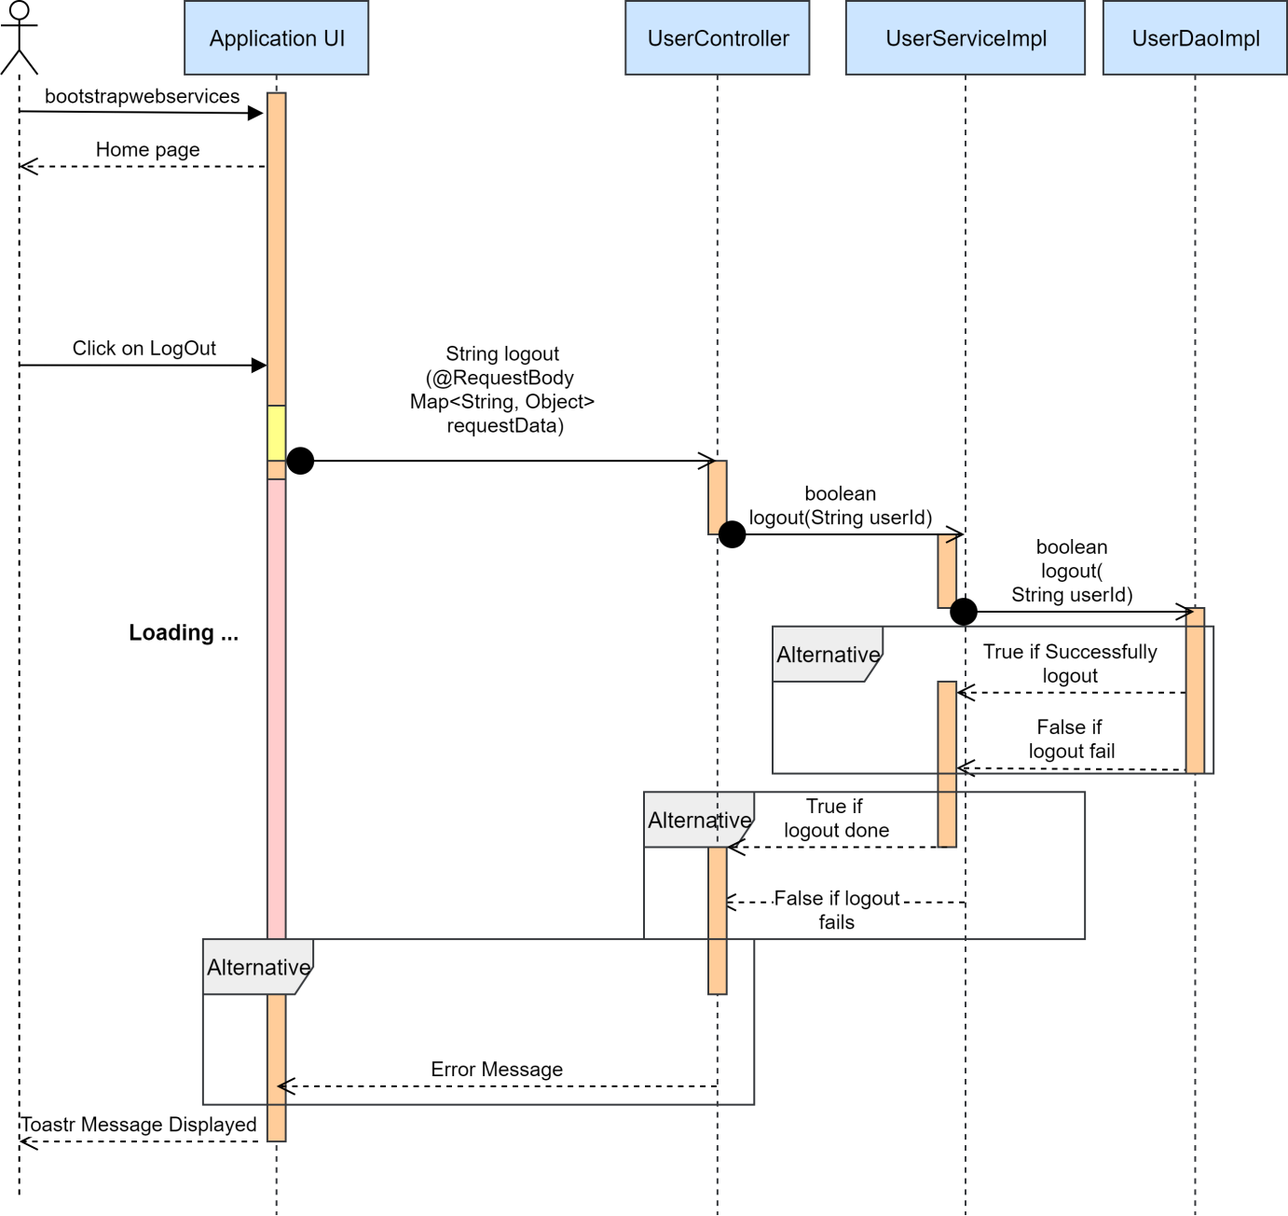

Sequence diagram of candidate updating CV information:

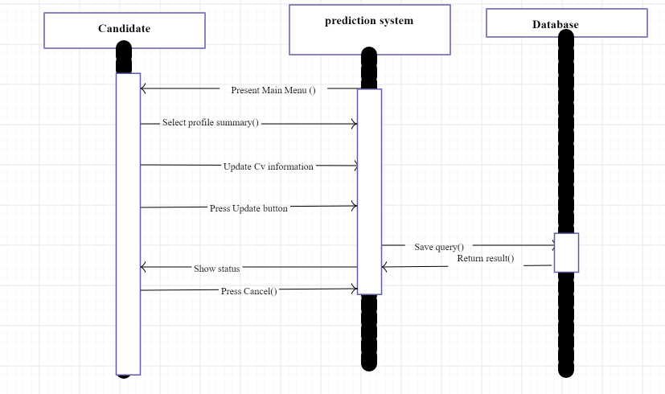

Sequence diagram for candidate:(job exploration)

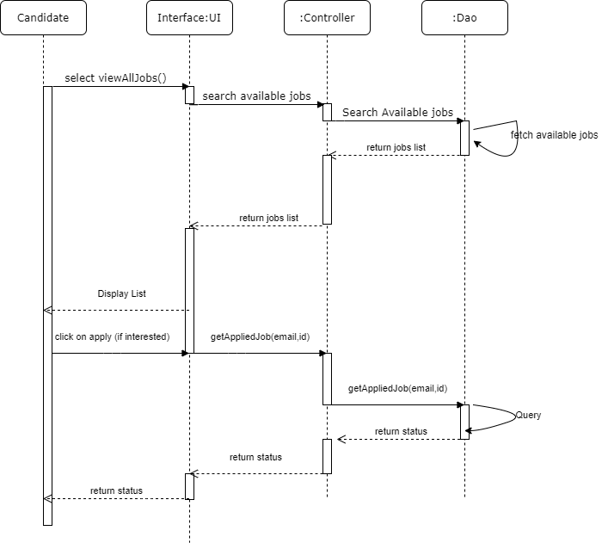

Sequence diagram for the candidate:(to view all applied applications)
